Idea Generation Techniques

Freewriting
- Set a discrete time period (perhaps 5 minutes) and write whatever comes to mind about your topic (or potential topic ideas).
- Don’t stop to fix mistakes, and don’t worry about deciding whether each idea is good or bad—just get as many on the page as you can. It helps to write fast when using this method.
- At the end of the time, pick out the sentences and key words that stand out to you. Use them as the basis for starting a paper, generating more material for an existing paper, or for another pre-writing activity from this list.

Looping
- Set a discrete time period (perhaps 5 minutes) and freewrite (see above).
- At the end of the time, pick one idea from the free write to focus on
- Set another discrete time period and do another free write, this time focusing only on this chosen idea.
- Rinse and repeat until you feel confident that they have a focused topic that you’re interested in writing about.

Listing
If it’s helpful, you can do this activity using note cards or post-it notes. If so, you can physically remove the ones that don’t work and keep the ones that might feel good. You can also use the remaining notecards (and add in more as needed) to begin paragraph mapping or otherwise playing around with the order/relationship of ideas. If you’re meeting with a writing tutor online, use the whiteboard option on zoom or a Jamboard (through google) to create this.
- Set a discrete time period
- List as many ideas, possible topics, etc. that come to mind
- At the end of the time, go through the list and eliminate ideas that aren’t exciting or won’t work for the assignment guidelines
- Talk through the remaining ideas—pros and cons of developing them further or using them for a main paper focus. You could do this with a writing tutor!

Thinking Out Loud
Sometimes it's easier to say what you mean than to write it: there’s often less pressure when talking about an idea than writing it down.
- Set a discrete period of time, like you would for free writing.
- The writing tutor can open a blank word document (and share their screen if online). You can talk out loud about your ideas while the tutor takes notes.
- Consider combining this with other pre-writing methods: you can use the “looping” method (see above) just like with free writing, use this as a set-up for mind-mapping or another pre-writing method, or just focus on pulling out individual ideas from the lump of ideas this generates

Mind mapping (clustering)
It can be helpful to create a visual of how your ideas connect and to see how specific your topic ideas can become. If you’re meeting with a writing tutor online, use the whiteboard option on zoom or a Jamboard (through google) to create this.
- Write your central idea or topic in the center of the page and circle it. Depending on where you’re at in the pre-writing process, this can be the thesis, or just a broad topic idea.
- Increasingly specific topics extend out from the center bubble, creating a mind-map. You can use this to create specific paragraphs or to just think about potential ideas more broadly.
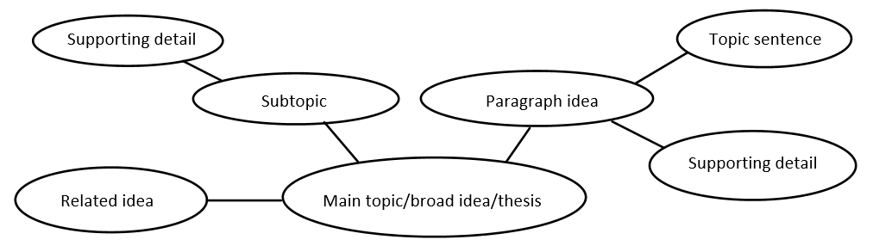

Outlining:
This could be used after paragraph mapping or mind-mapping. It’s a good way to transition from beginning thinking to the drafting process, especially if you are more visual or have difficulty organizing ideas once you are writing a draft.
- Take the central ideas from paragraph or mind-map and create an outline with each central idea as its own paragraph topic. You can write your topic sentences right into the outline or start with broad topics and go back to add detail later.
- Begin to fill in more detail as you generate ideas. For each paragraph, think of at least one or two pieces of supporting evidence. Break down the evidence into as many subpoints as you need to clearly explain it to your audience.

